Joint Special Operations Association
PO Box 72758
Fort Bragg, NC 28307
910-568-6127
membership@theJSOA.Org
www.theJSOA.org

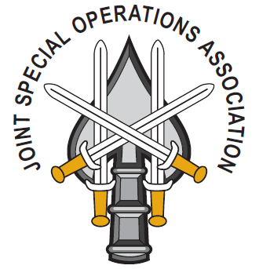
Application to become a member of the JSOA
The Joint Special Operations Association is an organization designed to bring together people with the common interest of supporting JSOC and the organizations that make up JSOC enterprise, the unit members and their families. We are a 501(C) 19, Tax Exempt Charitable Organization. Lifetime Membership - $120

Membership Type: Lifetime Date:_____________
Name: ________________________________ Date(s) Served in JSOC: ______________________
Directorate(s)/Unit(s): ______________________________________
Mailing Address: _________________________________________________________________ eMail: ____________________________________ Phone: ______________________________
Shirt Size for JSOA Polo: SM MED LG XL XXL XXXL Mens/Ladies

Guidelines:
- Membership in the JSOA shall be voluntary and is open to all service members and civilians assigned to JSOC, contractor personnel and augmentees currently working at JSOC for a period of at least two years, and to all former members of JSOC who left the organization in good standing.
- Membership will be open to all eligible personnel regardless of race, color, creed, religion, age, sex, disability, or national origin.
- Priority of membership will go to Combat/War Veterans. At no time will the membership level of Combat/War Veterans fall below 90%.
Are you a Combat Veteran? Y/N Campaign:__________________
Are you interested in becoming a JSOA board member? Y/N

Are you interested in volunteering to assist with the JSOA Store (Strahan’s M,W,F Lunchtime)? Y/N

Are you interested in volunteering to run or support any of the following?
Fundraising Committee Y/N
Golf Tourney Y/N
Membership Drive Y/N
Quarterly Newsletter Y/N
How can you help the JSOA become a more effective organization in order to better support JSOC?

_____________________________________________________________________________________________-

Joint Special Operations Association, PO BOX 72758 Fort Bragg, NC 28307
910-568-6127 – JSOA.Org@gmail.com – www.theJSOA.org

